May 6, 2015

Execution of financing documents for Greenko Group’s 120 MW Grid Connected Wind Power Project in Jaisalmer District, Rajathan, implemented through Tanot Wind Power Ventures Private Limited
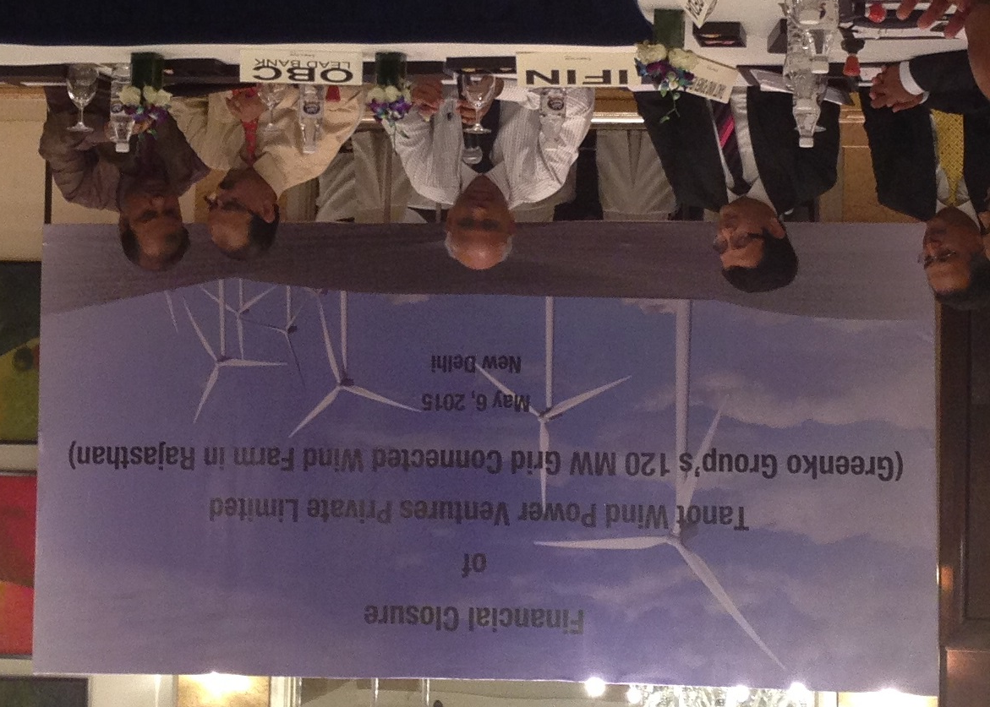
L to R: Mr. Vineet Agarwal (Head–Debt Distribution (North & East) & Structured Products, IFIN); Mr. Rahul Malik (VP, IFIN); Mr. C Purushotham (Director- Finance, Greenko Group); Mr. Ashwani Kumar (DGM, OBC-Lead Bank); Mr. K P Agarwal (Chief Manager, OBC)

IL&FS Financial Services Limited (IFIN) has successfully completed the debt syndication for the 120 MW Grid Connected Wind Power Project of Tanot Wind Power Ventures Private Limited (TWPVPL). The Financing Documents were executed in New Delhi on May 6, 2015 with a consortium of Banks led by Oriental Bank of Commerce

TWPVPL is an SPV of the Greenko Group, which is one of India's fastest growing Renewable Power Producers, focusing on developing clean energy assets. Greenko Group is promoted by Mr. Anil Chalamalasetty and Mr. Mahesh Kolli, first generation entrepreneurs. The group currently has operating capacity of over 700 MW in India with additional capacity in various stages of implementation

The project involves setting up of a 120 MW Wind Power Project in Rajasthan

IFIN is the Sole Financial Advisor and Arranger for the Term Loan aggregating to ₹6600 mn

