September 28, 2015

Execution of financing documents for RIDCOR Infra Projects Ltd (RIPL) for development of Rawatsar-Nohar-Bhadra and Mathura-Bharatpur & Gangapur-Bhadoti road stretches under the Mega Highways Projects in Rajasthan

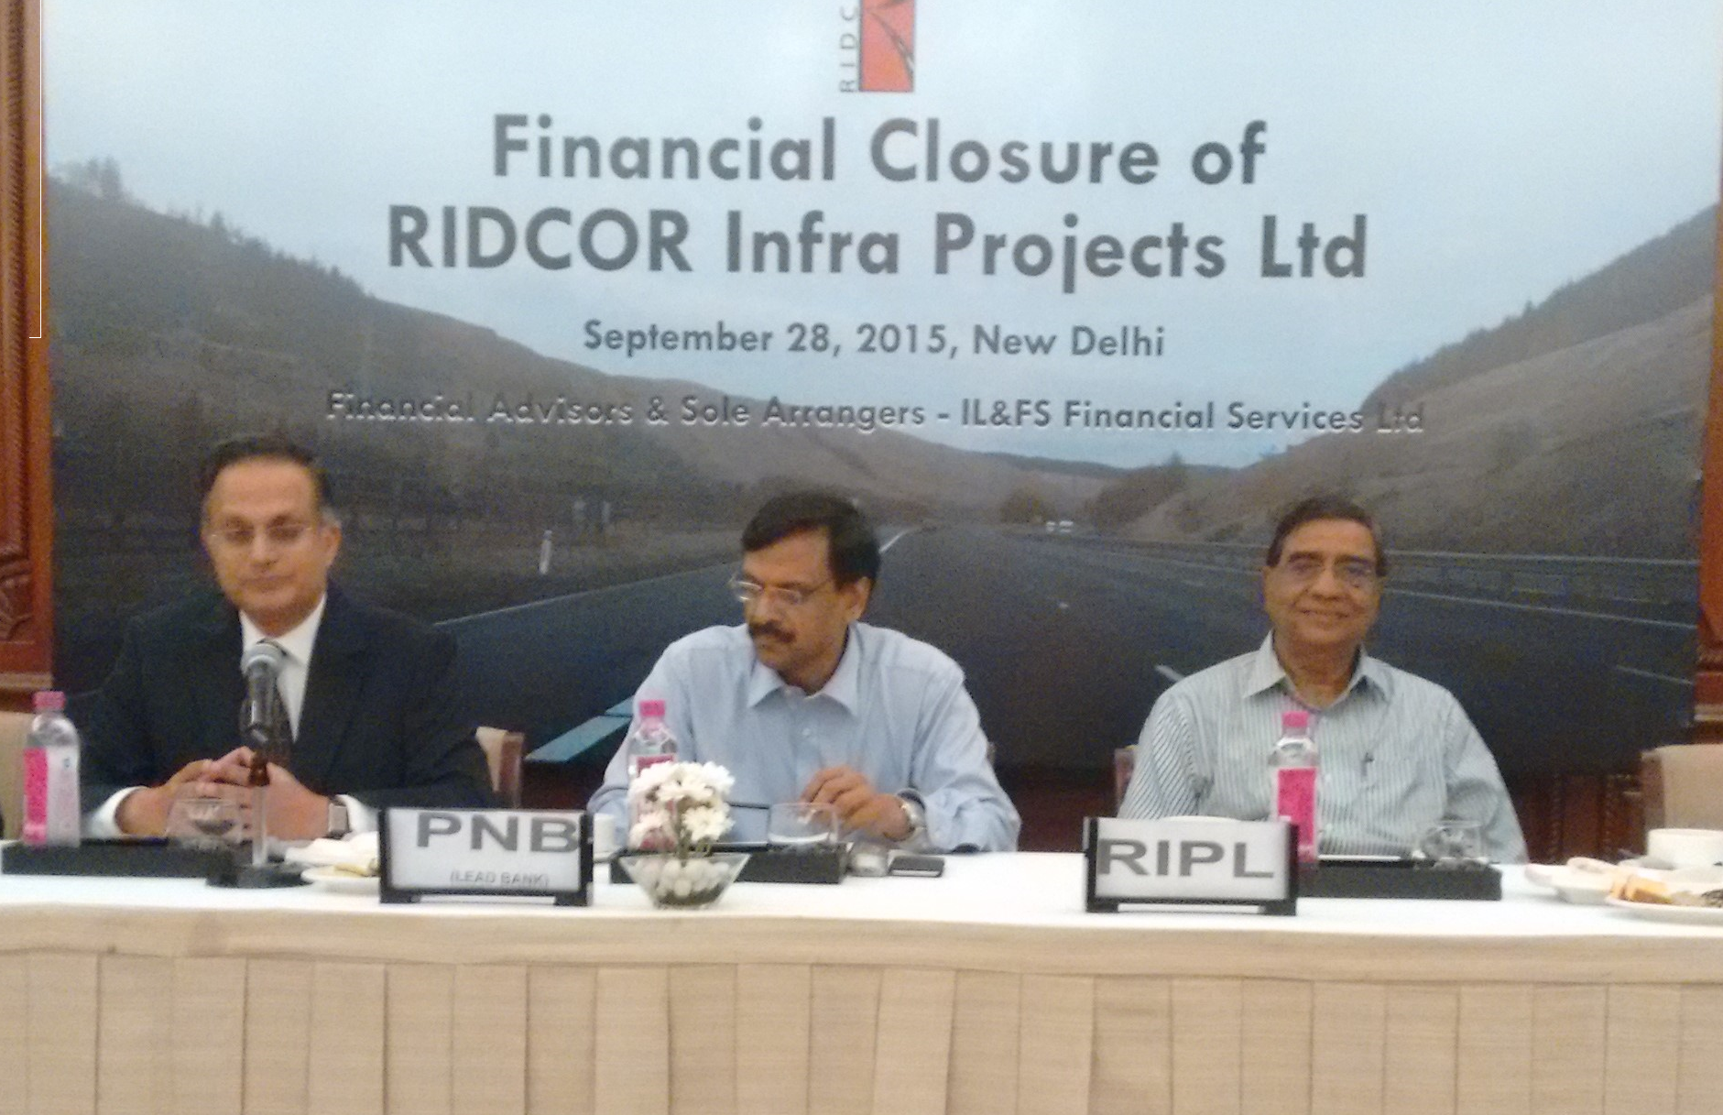
L to R: Mr. Vineet Agarwal (Head–Debt Distribution (North & East) & Structured Products, IFIN); Mr. Anil Bansal (DGM, PNB - Lead Bank); Mr. Harish Mathur (Chief Executive – RIDCOR & Director - RIPL)

IL&FS Financial Services Ltd (IFIN) has successfully completed the debt syndication for development of Rawatsar-Nohar-Bhadra and Mathura-Bharatpur & Gangapur-Bhadoti road stretches being undertaken by RIPL in Rajasthan. The Financing Documents were executed in New Delhi on Sep 28, 2015 with a consortium of Banks led by Punjab National Bank (PNB)

RIPL is a wholly owned subsidiary of Road Infrastructure Development Company of Rajasthan Ltd. (RIDCOR), which is a joint initiative of IL&FS Ltd. and the Government of Rajasthan (GoR) for implementation of Mega Highways Projects in Rajasthan. RIDCOR has already undertaken improvement of 11 State Highways stretches under the earlier phases aggregating to 1268 km till date. Based on successful execution of earlier phases, the GoR awarded these two additional stretches to be implemented by RIPL

IFIN has been the Sole Financial Advisor and Arranger for the Term Loan aggregating to ₹2977 mn

